VISVESVARAYA TECHNOLOGICAL UNIVERSITY
“Jnana Sangama”, Belgaum-590018 Karnataka State, India

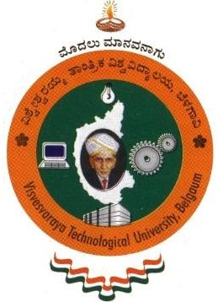

A PROJECT PHASE 1 REPORT
ON
“SMART FARMING SOLUTIONS FOR CROP DISEASE PREDICTION AND CONTROL USING IOT AND ML”
Submitted in partial fulfillment of the requirement for the award of the degree

BACHELOR OF ENGINEERING
IN
ARTIFICIAL INTELLIGENCE AND DATA SCIENCE

Submitted By:

A CHETAN KUMAR REDDY 1SJ22AD005
MALARAPU AKASH 1SJ22AD021
YEDDULA REVANTH REDDY 1SJ22AD063

UNDER THE GUIDANCE OF:
Mr. Darshan A
Assistant Professor
Dept. of AI&DS, SJCIT


S J C INSTITUTE OF TECHNOLOGY
Department of Artificial Intelligence and Data Science

Chikkballapura – 562 101

